Sean Yang

11/29/18

Pd 4

Journal Report 10

I got a new laptop that is faster so the program runs faster now. The new laptop is running windows while my old one ran Linux. The capture script didn’t work on Windows. Since I didn’t want files with the same names, I used str(datetime.datetime.now()) as the file names. However, it couldn't save the images. Initially, I thought it was because Windows uses backslash instead of forward slash. However, that wasn’t the problem. Later, I discovered that opencv couldn’t save files with colons in the filenames on Windows. I was able to fix the issue.

My classifier works for three gestures now. However, it didn't work unless the camera was at a certain distance with the face. This is because the feature vectors weren’t normalized. I normalized the feature vectors by dividing each vector by the distance between point 27 and point 29. The classifier works better now.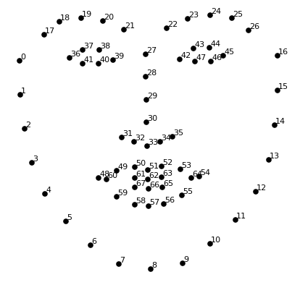

The classifier still has some minor issues. When my face is neutral and tilted, the classifier recognizes tilted neutral face as a non-neutral gesture. This is because I don’t have enough tilted neutral training data for recognition. I also can address the issue by rotating all of the points around the center of the face. I noticed that the key point detector is not accurate when the face is tilted. 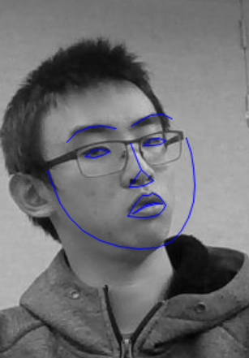

I’d rather see non-neutral gesture not being recognized than accidentally flip a page. Since the processing speed for the classifier is faster now, I can check for continuous frames of non-neutral gestures to eliminate the impact of misdetections.

